**Appendix C - Group report front page**

You will include the following information on the first page of your group report.

**CMT307 Coursework 2 Group Project**

|  |  |
| --- | --- |
| **Group number** | G19 |
| **Project title** | Energy Usage Prediction |
| **Supervisor** | Hanzhi Wang |
|  | 21126107 MP  1840386 Matt  1823122 Ed  1823789 Ben  21088472 Bilal  21014978 Mingtao  21123124 Zainab  21099797 Joy |

1. Introduction

Nowadays, where global demand for energy increases and prices increase, there is also a strong need to reduce waste when possible. Thus, a prediction of energy usage is an important step that can allow humans to use energy more efficiently, and consequently more economically. This is crucial to reduce the negative consequences of global warming. To meet international regulations regarding environmental issues, such as the 2DS pathway for global climate change mitigation designed by International Energy Agency (IEA) [1]. The pathway aims to keep an increase in global temperature lesser than two Celsius degrees by 2100. To meet the purpose it is highly required to maintain annual growth in energy consumption at the rate of 1.2%. However, the current rate is 2.9%. Thus, it is desirable to create a system that can forecast energy use so that IEA's establishments can be met. Also, a successful prediction of energy usage would reduce wastage, which is highly advantageous for energetic companies, governments bodies, and human beings.

Energy usage prediction is a great task for Machine Learning (ML), which can be seen as nonlinear time series with numerous complex factors/variables. These include a variety of building stocks such as public services, residential and industrial, weather changes, as well as periods of a year such as holidays, Christmas, etc. Also, there might be sudden changes in energy consumption due to unexpected events like equipment failure or blackout. Thus, it is extremely important to develop models which will have a wide exposure to various factors and will bring accurate results. Precise predictions will help us in achieving the following goals:

* Creating a reliable ML model that can effectively predict the use of energy in various categories of buildings in the following areas: hilled water, electric, hot water, and steam meters, and different weather conditions
* Gaining valuable insights into factors affecting a building’s energy demand, which allows managers to improve energy efficiency
* Enable managers to identify anomalously high/low energy consumption and alert them to problems with buildings

2. Literature Review

The use of Machine Learning (ML) techniques in predicting future energy demands is a field that has been widely explored. Through various trials and studies, artificial neural networks (ANN) have been determined as one of the more effective techniques and is now readily used to produce accurate results (Seyedzadeh et al., 2019). After researching, it has become clear that recurrent neural networks (RNN) are particularly efficient when using historic energy usage data as the input (Tun, Y.L et al., 2021). RNN’s loop like structure produces a time delay, which is especially effective when utilizing temperature data (Sun, Y et al., 2020.).

Whilst RNN has been widely used within this field, it also commonly acknowledged that the basic model of RNN has its limitations and drawbacks. Since we are interested in long term energy prediction as well as short term, a naïve RNN has a tendency to forget old information due to the commonly known vanishing gradient problem. To tackle this problem, we instead implement LSTM-RNN model (Berriel, R.F et al., 2017).

The LSTM-RNN model was introduced by Hochreiter and Schmidhuber (1997). In the LSTM model, the summation units of the RNN model are replaced by memory units, providing the LSTM model with the capacity to store and recall information for longer (Heidari, A et al., 2020). The LSTM model has been successfully implemented to forecast energy demands and produced accurate results, some examples of this include (Wang, J.Q et al., 2020) and (Rahman, A et al., 2018).

There has also been some literature that has made us aware of some of the potential drawbacks in using this model. (Rahman, A et al., 2018) found that the LSTM model assumes knowledge of future weather conditions and does not consider any potential changes in weather. Hence, should the weather differ significantly from our weather training data, there most probably be a loss in accuracy in our model. Secondly, there have a number of studies that have noted difficulty in hyper-parameter tuning for this model. For example (Kim, T et al., 2019) noted it took a large amount of trial and error in order to find the optimal parameters. (Ding, Z et al., 2021) noted that it took a combination of trial and error, grid search, random search and Bayesian optimization in order for the optimal parameters to be found.

Keen to explore different avenues of approach for this problem we decided to investigate further possible models we could use. After some research we decided that using a K nearest-neighbours (KNN) would be a suitable technique. KNN is used often in the field of prediction, but as of yet has not had much in energy prediction (Olu-Ajayi, R et al ., 2022). That being said, there are a number of studies that demonstrate that KNN can be used effectively in this field. (Wahid, F et al., 2016) and (Troncoso Lora, A et al., 2003) are both examples where KNN has been used to produce accurate results. (Deb, C et al., 2017) also discuss a variety of different studies where KNN has been used on its own and in a hybrid model and produced accurate results.

(Deb, C et al., 2017) mentions a common drawback when trying to implement a KNN model is it can sometimes be difficult to select the optimal value for k. When determining our optimum value for k, we will follow a similar approach used by (Long, H et al., 2014), in this study they loop through a range of values for k and select k based on the lowest RMSE score. We intend on doing the same however we have also decided to consider the value.

Thirdly, we have decided to implement a decision tree model. There have been a sufficient number of successful studies that have given us enough confidence in this model. However, from our readings we have understood for the ease of use and the fact that decision trees are typically computationally inexpensive comparatively to other models, we may be giving up a small amount of performance (Amasyali, K et al., 2018). Based on our research we are under the impression that to produce accurate results with LSTM-RNN and KNN, it may be difficult and time consuming. Thus we are happy to potentially lose a small amount of accuracy, as this will allow us to explore different techniques and produce further results to analyse and discuss. Nevertheless, there are still examples of decision tree models that have produced accurate results. (Yu, Z et al., 2010) used a decision tree model for energy demand prediction in buildings and their model provided 92% accuracy. In addition to this, (Tso, G.K et al., 2007) found that out of a neural network model, regression analysis and decision trees, it was in fact the simpler decision tree model that produced the best results. It is worth noting that this study was carried out in 2007 and hence there have been developments in machine learning techniques since then. Regardless, we are optimistic for all of our models and are looking forward to see the outcomes.

1. Description of the task and dataset

Dataset comes from Kaggle’s ASHRAE competition. It consists of data/readings from over 1,000 buildings over a three-year timeframe. The dataset consists of five CSV files. The building data file consists of 6 variables that provide information on buildings’ primary use, covered area, built year and floor count with a number of values ranging from 0 to 1448. Next, there are training and test data files for weather readings. They consist of 9 variables that provide information on air temperature, cloud coverage, dew temperature, precipitation depth, sea pressure, wind direction and wind speed. Lastly, there are two files, test and training both of which provide details on buildings meter readings. Overall there are thirty-four columns that have four data types: decimal, integer, date and string.

To measure a quality of developed models the following evaluation metrics: Root Mean Squared Logarithmic Error (RMLE).

The RMLE is calculated as

Where:

– RMLE value(score)

n- number of observations in the public/private dataset

– prediction of target

– actual target for i

log(x) – natural logarithm of x

RMLE was suggested to be used because it is a common metric for regression problems. It is an extension of Mean Squared Error (MSE). However, for the energy prediction, RMLE is better because it is more robust to the outliers. When a relative error is considered, also RMLE is a more preferable choice because it considers the relative error between the Predicted and the Actual value and the scale of the error are not significant. On the other hand, the RMSE value Increases in magnitude if the scale of error increases. The most unique property that differentiates RMLE from MSE is fact that the RMLE penalizes the underestimation of the actual value more severely than it does for the Overestimation. preferable because the dataset has a wide range of target variables

To ease the analysis of the dataset, merging techniques were used. A merge was performed on three train data files and two test files to obtain a single test and training dataset. It is crucial to observe that nine out of sixteen variables have large missing values that need to be adjusted at a later stage. (Fig-1) In order to explore timely variations, we broke the timestamp variable into six new columns: hour, day, dayOfWeek, dayOfYear, month and year in order to explore timely variations in data.

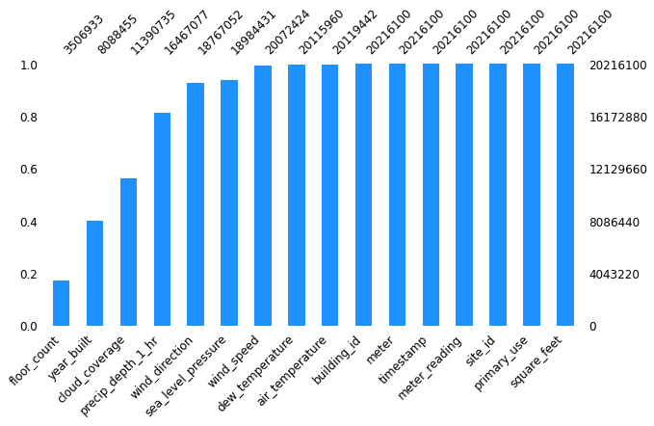

Figure 1-Missing Values in Training Data Set

3.1 Exploratory Data Analysis

Once the data was combined we started exploring the target variable of meter reading. Firstly, a log transformation of the variable was taken to adjust for high skewness and then plot a density graph that shows a good variation in values along with a high number of 0-meter reading values. Then an exploration of any seasonality changes was made by plotting meter readings against time.

Firstly it was explored distribution of meter reading. Initial distribution is skewed to the left thus log transformation was applied to reduce the skewness.

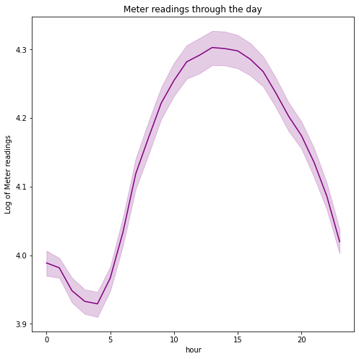

Figure 1 shows energy usage throughout the day. The energy usage is reasonably very low during the early morning hours and fairly high during the evening as it is the peak working time of all operating sites such as educational institutions and industrial areas.

Figure 2 shows the energy usage per annum. It can be observed that energy consumption is fairly low during the starting months of the year, rises sharply in the spring season and fluctuates during the summer season. June-September summer months report the highest level of energy consumption which may be due to the high AC usage in offices and institutions

Both bar plots show the distribution of meters at the building (fig.a) and energy consumption from each of these meter types(fig. b). Electricity meters are the most commonly used by chilled water and steam meter types. Also, steam and chilled water meter types consume the greatest energy followed by electricity type. It might be useful to replace hot water meter type with steam as it can greatly save energy.

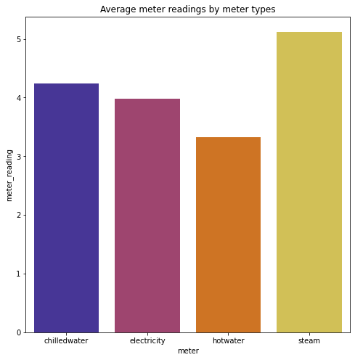

Since data assumes energy consumption in various types of buildings, it is worth exploring meter reading distribution based on primary usage in different areas. It is seen that educational institutions, offices and retail sites have the most energy consumption during the morning and evening time of the day and the least consumption during the night. This result is quite expected as these sites mostly have fixed operational timings. For entertainment and public assembly sites, there is low energy usage during night times and greater energy usage during evening times. For residential areas, there is a sharp decline after midnight and then meter reading keeps on increasing and reaches a high level and remains stable until midnight. This result is directly related to the higher level of activities being performed throughout the day in a house that utilizes various appliances. Also, an overall analysis of the graphs shows that utility, industrial, healthcare and food sales sites report higher levels of energy consumption whereas worship areas and retail sites consume a lower level of energy.

2.1.1 Analysis of weather data

A density plot graph shows that air temperature variable follows a normal distribution. The mean value of air temperature is between 14 and 15 degree Celsius and most values lie between the range of 0-30 degrees. Cloud_coverage is measured between a 0 to 9 scale where 0 means it is a clear sky and 9 means it is rainy. It can be observed from the density plot that most of the cloud coverage is zero. Sea level pressure follows a normal distribution with most values in the range of 1000-1025. Dew temperature has a skewed distribution with most values between 0-25 degrees

This windrose diagram shows that for majority of the building sites, the wind mostly blows from the north direction with its speed between 0 to 3.8 m/s., followed by then south direction. Also, the North East direction has the minimum wind pressure.

2.2.2 Analysis of building data

From the above analysis, it is clear that most of the buildings were built around 1975. The growing trend is maintained before 1980. A second growing trend is observed after 2000 with a peak around the 2010 year. Average meter readings greatly fluctuate with the year built variable with no clear trend. Such fluctuations were difficult describable and there is no valid rationale why they happened. Moreover, most of the buildings have 0-15000 covered square feet area and they have two floors. For a floor count greater than 10, meter reading has a drastic increase, then around 14 floors have a sharp decrease and then again for floor count greater than 15 there is a drastic increase.

* + 1. Correlation Matrix

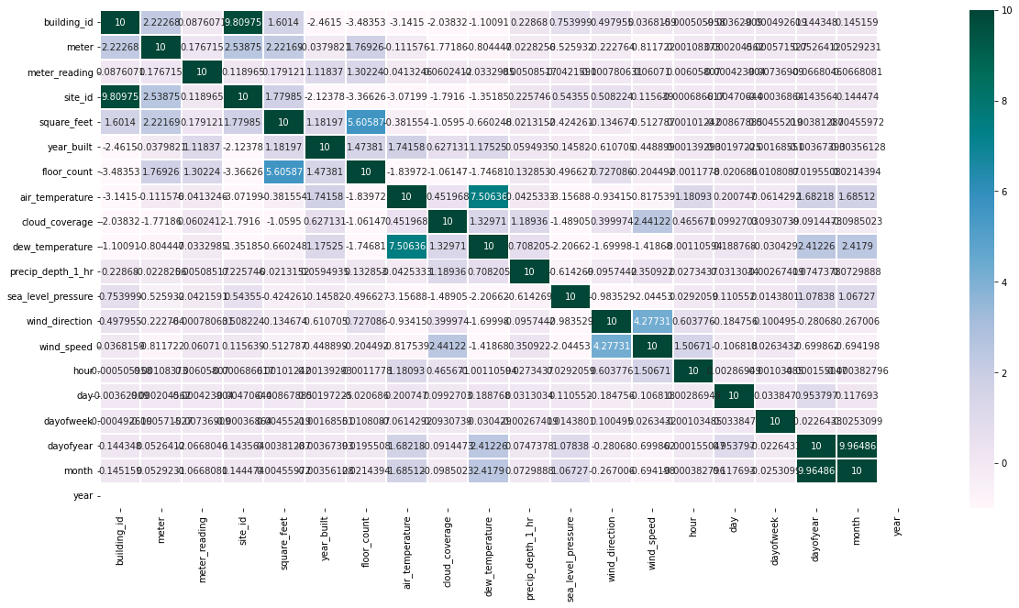

It is useful to plot a correlation matrix to understand relationships between feature variables. We can conclude from the above figure that Square_feet and year_built have a positive corelation with the target variable. The greater the size of the building, the more energy it consumes. Also, Air_temperature is highly correlated with dew_temperture and Square_feet is correlated with floor_count. However, most of the features are less in correlation with meter reading.

1. Methodology

**Lightbgm**: This is a gradient boosting framework, using tree-based learning algorithms. By using gradient based one side sampling and exclusive feature bundling, the lightbgm a very lightweight and fast algorithm. It is mainly implemented on large datasets due to it being prone to overfitting small datasets. Whilst a decision tree splits the tree tree-wise, the lightbgm algorithm splits the tree leaf-wise.

**RNN**: A recurring neural network is a form of machine learning that returns on itself to increase accuracy. For a typical neural network, firstly, an example from a dataset is loaded (in this case, the training data supplied). The network takes that example, and applies mathematical formulae to it using random variables, yielding a predicted result. Using the validation data, this prediction can be compared, and the difference between them will give an error. Returning the error back through the same path will adjust the variables, and this is all repeated until the variables are defined with minimal error. The recurrent neural network takes this a step further, by instead of taking in one example at a time and producing one result, it takes multiple neural networks which feed information to each other. This allows for a low time complexity and makes it suitable for dealing with large datasets.

**Decision Tree**: The decision tree uses rules learnt during its training phase to make decisions. You begin with the root node, which splits off to two different regions. These regions also split into a further two different regions and this process continues. The decision tree uses the rules supplied to decide which region to go to at a node, and this process is continued until all the rules are applied or until there are no data points left. The decision tree time complexity is of form O (n log(n) * d), where d is dimensionality in the data. A random forest uses multiple decision trees with an element of randomness for more accuracy, however due to the multiple decision trees the computational memory cost is significantly higher than that of a single decision tree.

**KNN**: KNN works using ‘feature similarity’ to predict the values of new data points. Effectively, new points are assigned based on its resemblance in comparison to the training dataset. The value of k can be adjusted, such that more of the data is included in a single prediction. This algorithm can be used for either classification or regression, however for large datasets it can be extremely costly in terms of memory in comparison to other models with a time complexity of O (n) for testing.

1. Experimental Setting

As part of the pre-processing, one of the main factors was memory usage due to the large nature of the data. Converting the data to feather files and applying a function to reduce the memory usage (mainly by converting int64s to int8s, or float64s to float32s) allowed us to run the programme more efficiently with very little loss of data. The data was also merged with the weather data and the building data to allow for more features to be selected, and the timestamp was broken down into hours, days, day of the week, day of the year, the month, and the year, which allows us to get the exact date in integer values. A log transformation was also applied to the meter reading and square feet, which was done to account for the large range of values and make the training of the model more effective. Furthermore, months were added along with an ‘isDayTime’ Boolean in form 1 or 0, 1 being it is between the hours of 06:00 and 18:00. The feature selection allowed us to remove various features from the data to acquire a better result from the data.

5.1 Decision Trees

For the decision trees model, the log transformation was not used as converting the raw train meter readings to integer values instead produced higher accuracy rates. However, to achieve accurate results it also required a large enough maximum depth which, in turn, increases the complexity, and therefore memory usage of the model exponentially.

With these adjustments, the hyperparameters that were found to have the greatest impact were the random state and max depth of the trees. To tune these hyperparameters, a small sample from the train data was looped and the highest accuracy values for these were found.

As expected, the random state showed a random distribution of accuracy values, and therefore the highest point the most accurate value that was tested was used. This hyperparameter is especially valuable when considering that the random state of the value has very, negative effects on memory or performance of the model.

Figure N shows an inverse logarithmic shape, with it plateauing at roughly 40. Therefore, any value above this would cause the model to be unnecessarily complex and cause performance issues. However, the memory requirements of the max depth value of 40 was far too great for our computational resources. The value of max depth 14 was the maximum possible with the computational power available and was therefore the compromise used.

Conclusion